signInAuthenticationFailed1658953759903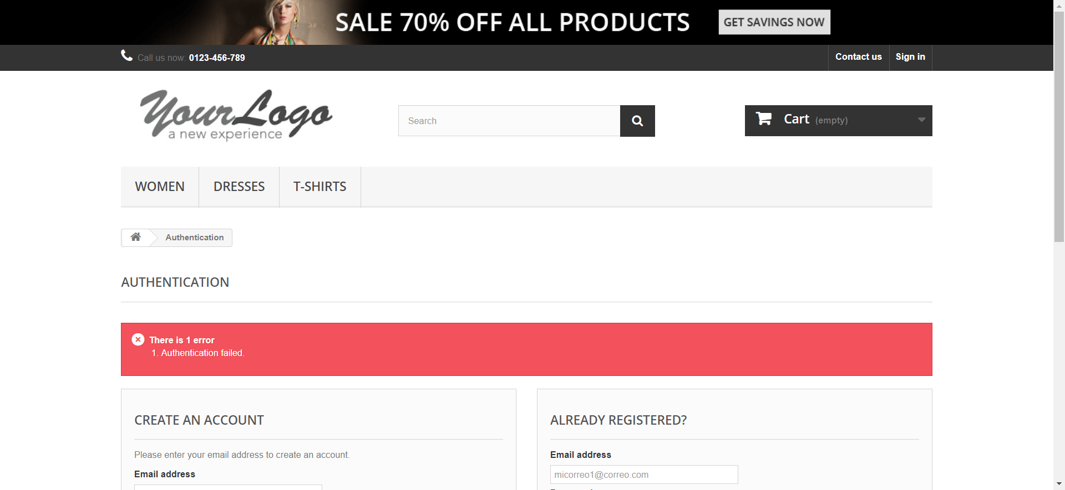

signInEmailInvalido1658953779625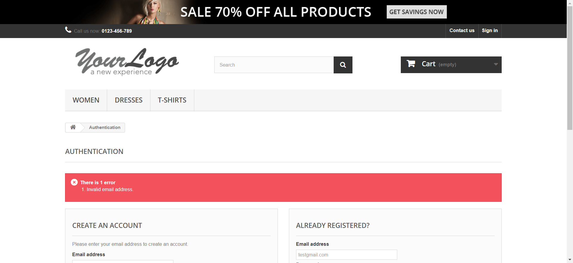

signInEmailInvalido1658953789224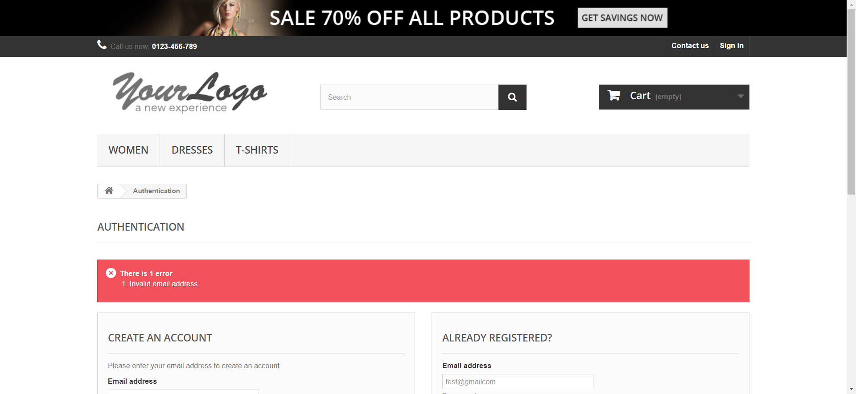

signInEmailInvalido1658953800708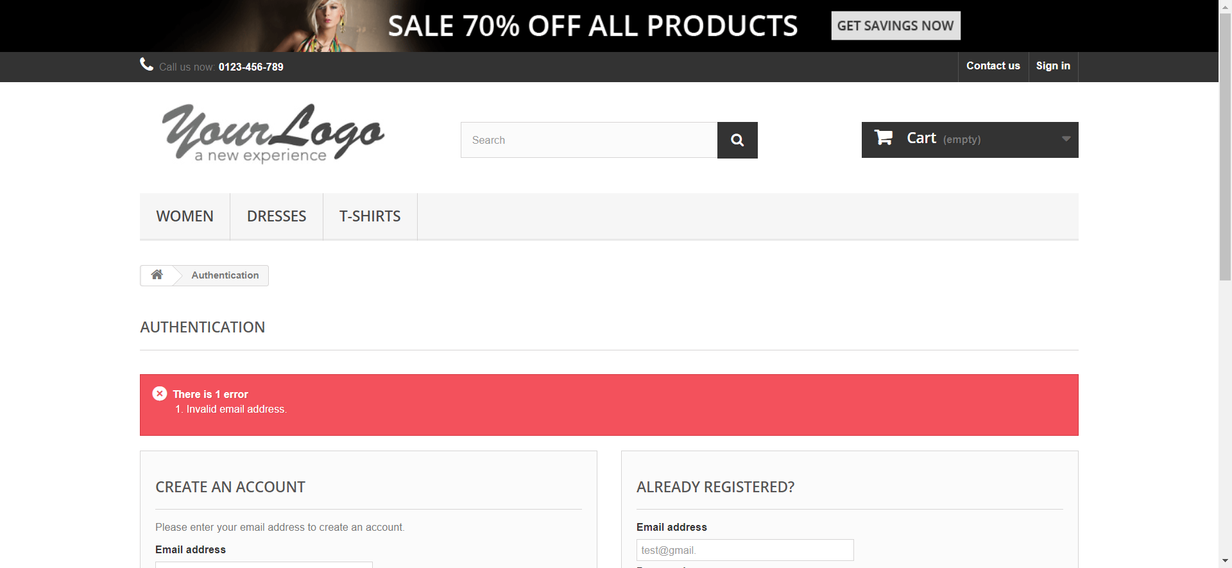

signInInvalidPassword1658953808904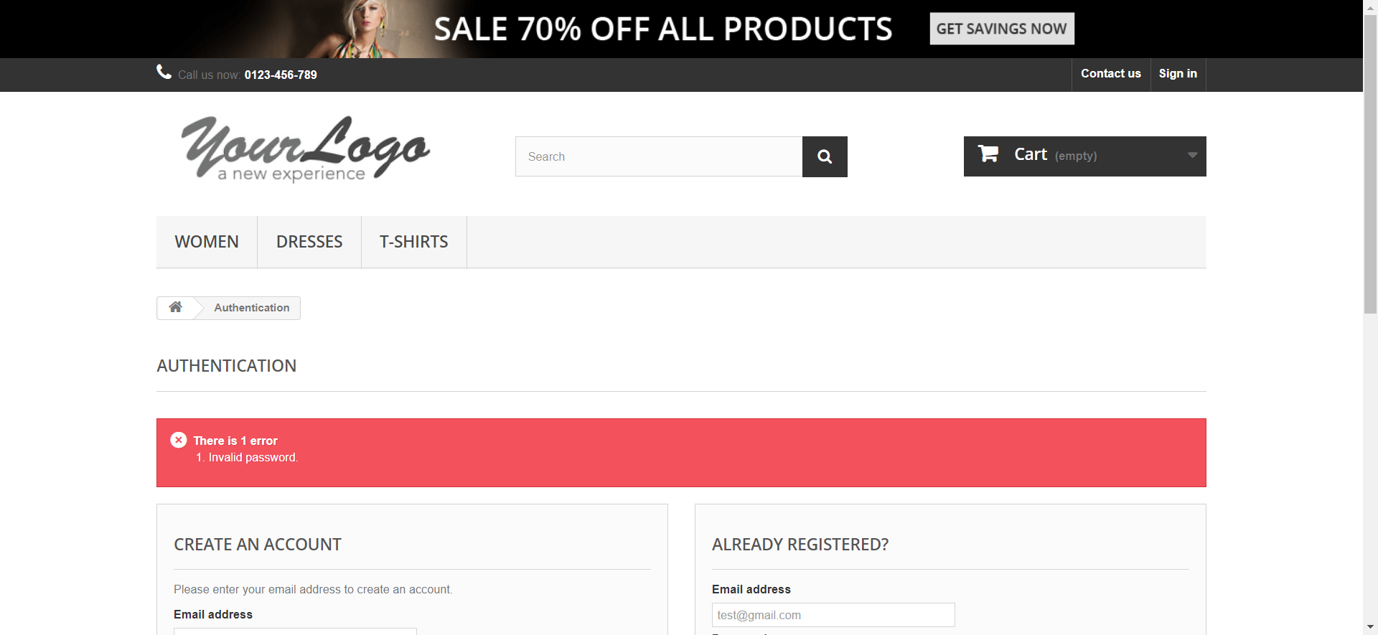

signInInvalidPassword1658953820217

signInInvalidPassword1658953828081

signInRequiredEmail1658953836996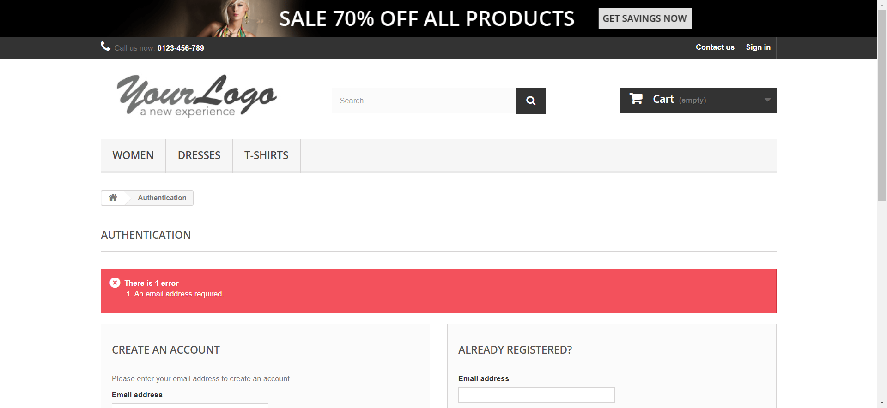

signInRequiredEmail1658953849480

signInRequiredEmail1658953861802

signInRequiredPassword1658953872979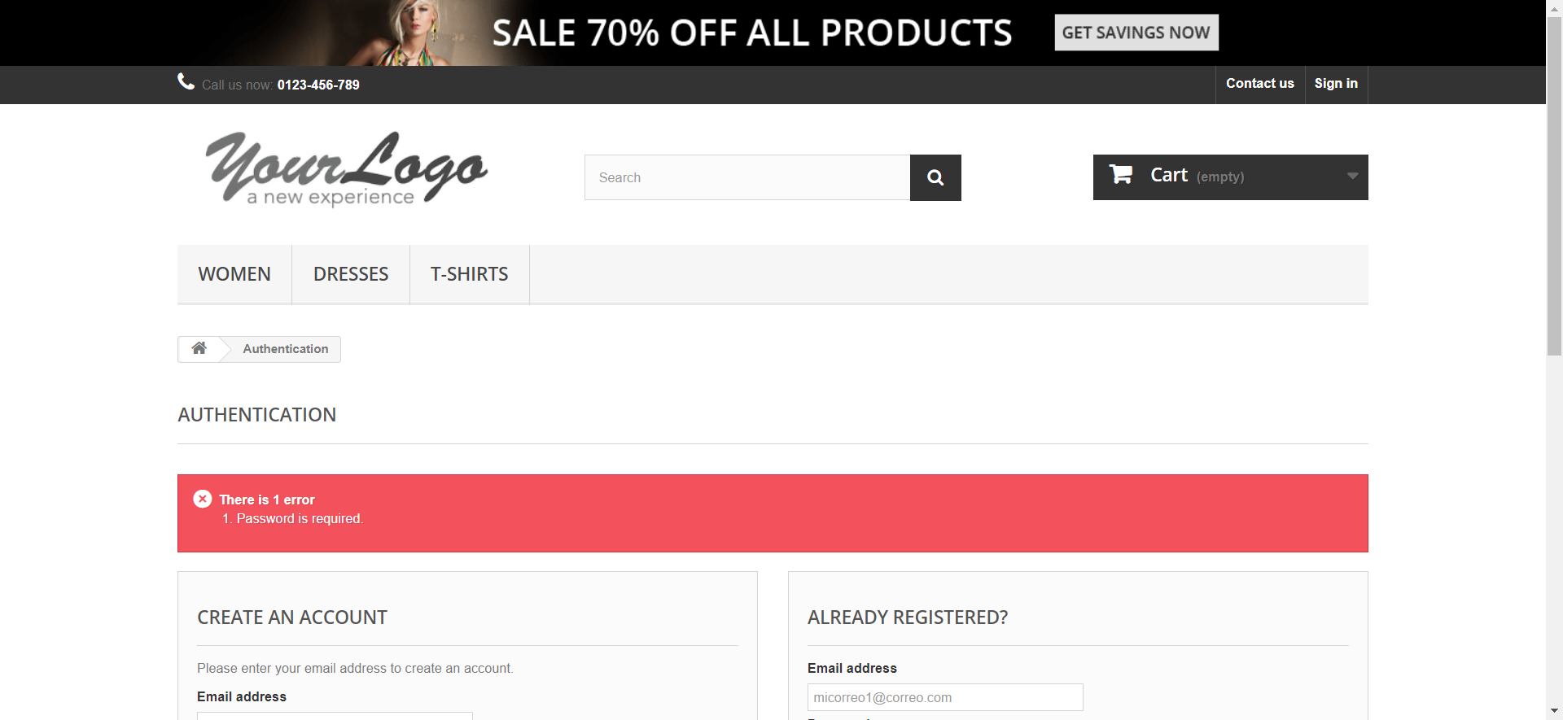

validSignIn1658953882608